**E-Mart: Online Shopping**

***Slogan: Keep learning to live healthier and longer.***

**=============================================**

**Group EriDev:**

* + Tesfai Gebrekidan ID:110464
  + Aaron Gezai ID: 109660
  + Yared Beyene ID: 110466
  + Wina Merhazion ID: 610591

**=============================================**

**INTRODUCTION**

The e-mart is an application that provides customers with online shopping. Through a Web browser, a customer can browse the catalog, ***place items to purchase into a shopping cart***, ***create and sign into a user account***, and **purchase the shopping cart contents by placing an order with a payment card.**

**PROJECT DESCRIPTION**

The web application will include a login page which will be able to identify the user whether he/she is an employee or a customer. Based on their roles, user will reach to authorized views(pages).

If the user is an administrator, he/she will be able to add products and assign designated shippers to each order made by customers. Once the administrator logged-in he/she will reach a page that will grant them to perform specific operations such as adding products to the website, assigning a shipper to deliver products to customers and preform CRUD operations on products.

If the user signed in as a customer, then he/she will get a different view with different operations. The customers will be able to view products available for purchase, add/remove items to their shopping chart and finally pay and checkout their orders. During checking out, they will be able to enter billing and shipping address.

Once a customer has decided on purchasing an item, he/she will be able to fill in their payment method and billing information to which will be verified both in the client and server side for extra security.

|  |  |
| --- | --- |
| **Project Proposal** | |
| **Project Title:** | **E-Mart** |
| Project Rationale | * The project intention is to make people’s day to day activities easy by order items online. |
| Project Purpose | * The project will alleviate the time it takes to go and buy items on site. * Helps people to compare products from different suppliers easily and select the appropriate one. |
| Project Goal | * By the end of the project, customers will be able to order items online and the items will be delivered in the specified date by the assigned shipper. * customers will be able to pay online using their payment card |
| Project Objective | * Enabling customer to login and purchase products through adding and removing items from the cart * Enabling admin to assign shipper to the order product for delivery * Authorized employees to add, categorize * View products in website * Customers are able to pay and checkout items after proper validation |
| Anticipated benefits | * E-mart will be able to bring the customers closer to getting what they want with ease. * Providing an easy interface and security which is trust worthy and dependable * Enabling work to be outsourced to shippers will generate more jobs for other companies |
| Key Success Factors | * Enabling third party supplies to showcase their products in our platform will provide more variety of products to offer for our customers. |
| Quality Definition | * Testing on interface will be implemented to ensure that our platform will be scalable and secure of any faults. |
| Major Deliverables | * User will be able to sign up and login * Administrator will be able to sign up and login * Users will be able to view products and add into their cart * Administrator will be able to add to inventory * Security checks will be done on login for both users, on both client and server side * Security checks will be done on client side and server during payment |
| Estimate time frame | * 5 days |
|  |  |

**ARCHITECTURAL DIAGRAM**

We are trying to show the system wise architect of our final project in the following diagram

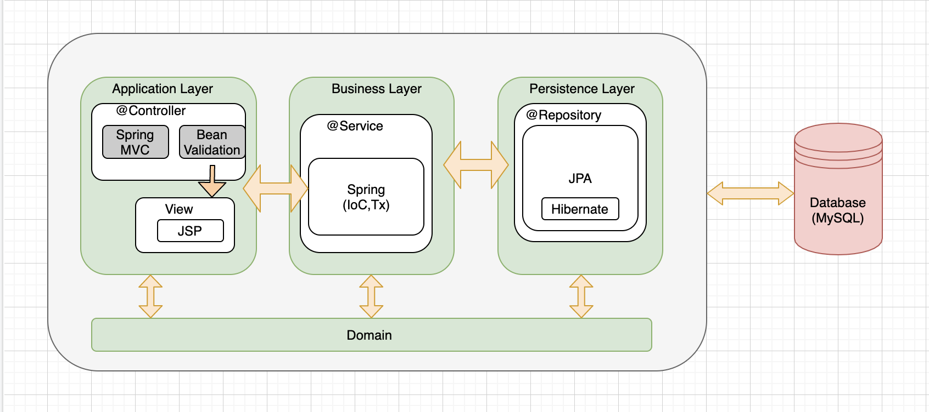

**TECHNOLOGIES USED**

We are planning to use the following tools and technologies in our final WAA course project.

1. Spring web MVC
2. Spring security
3. Spring JPA and Hibernate Validation
4. Hibernate to implement ORM
5. Internationalization
6. Tiles
7. JSP
8. Spring tag Library
9. MySQL Database
10. Exception handling
11. JUnit
12. Mockito
13. Ajax if necessary
14. IntelliJ and Spring tool suite IDE
15. Apache Tomcat
16. Maven
17. Bootstrap
18. Github
19. StarUML

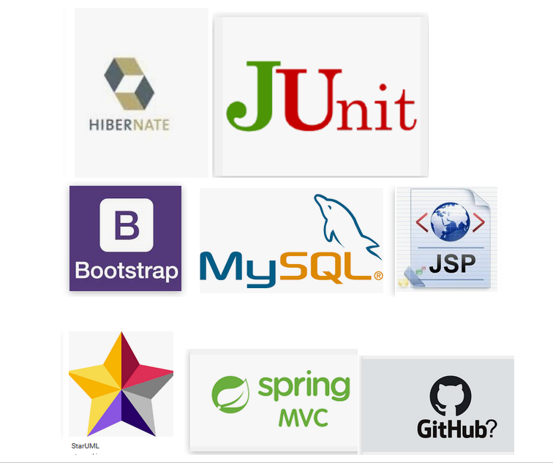

**USE CASE DIAGRAM**

Here are the major use cases that we are going to have in our project

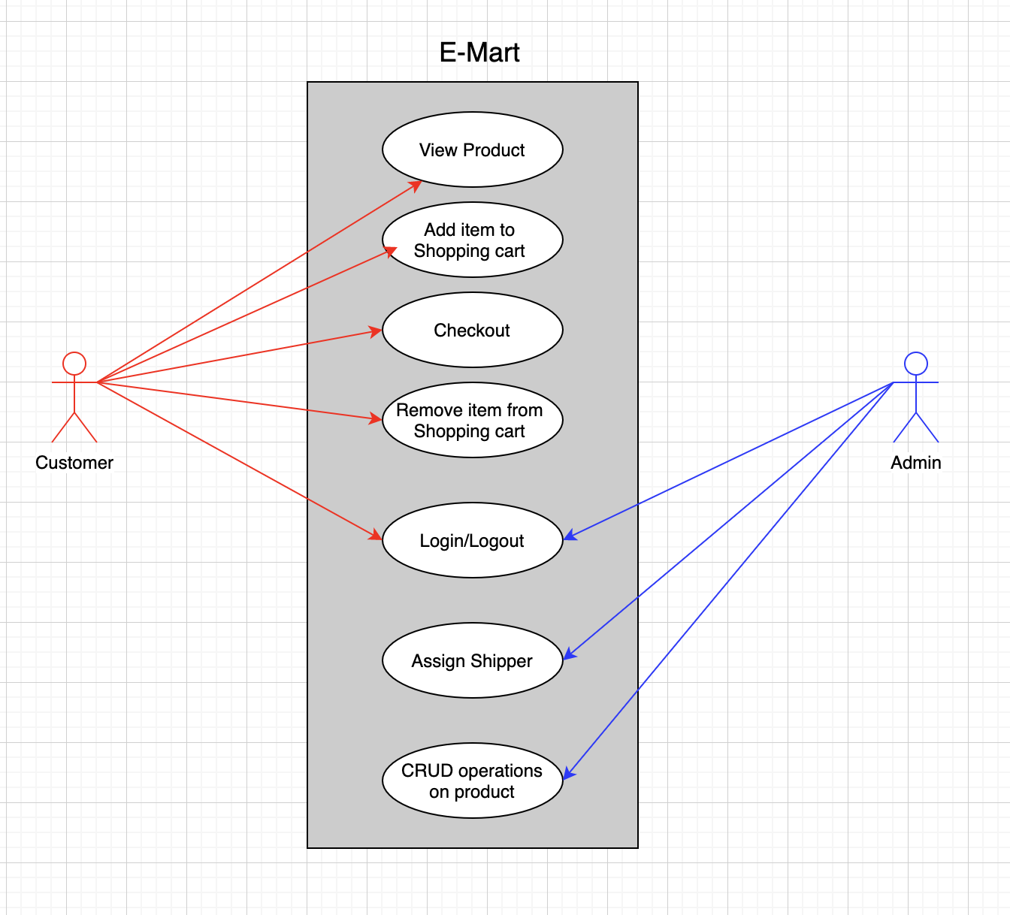

**CONCLUSION**

This proposal is our draft to the final project. In the coming days we are going to enhance. We can add some technologies other than these listed above, and we can drop off some as well. Most important is regarding the use cases. These mentioned above are the major use cases. We can have some more.